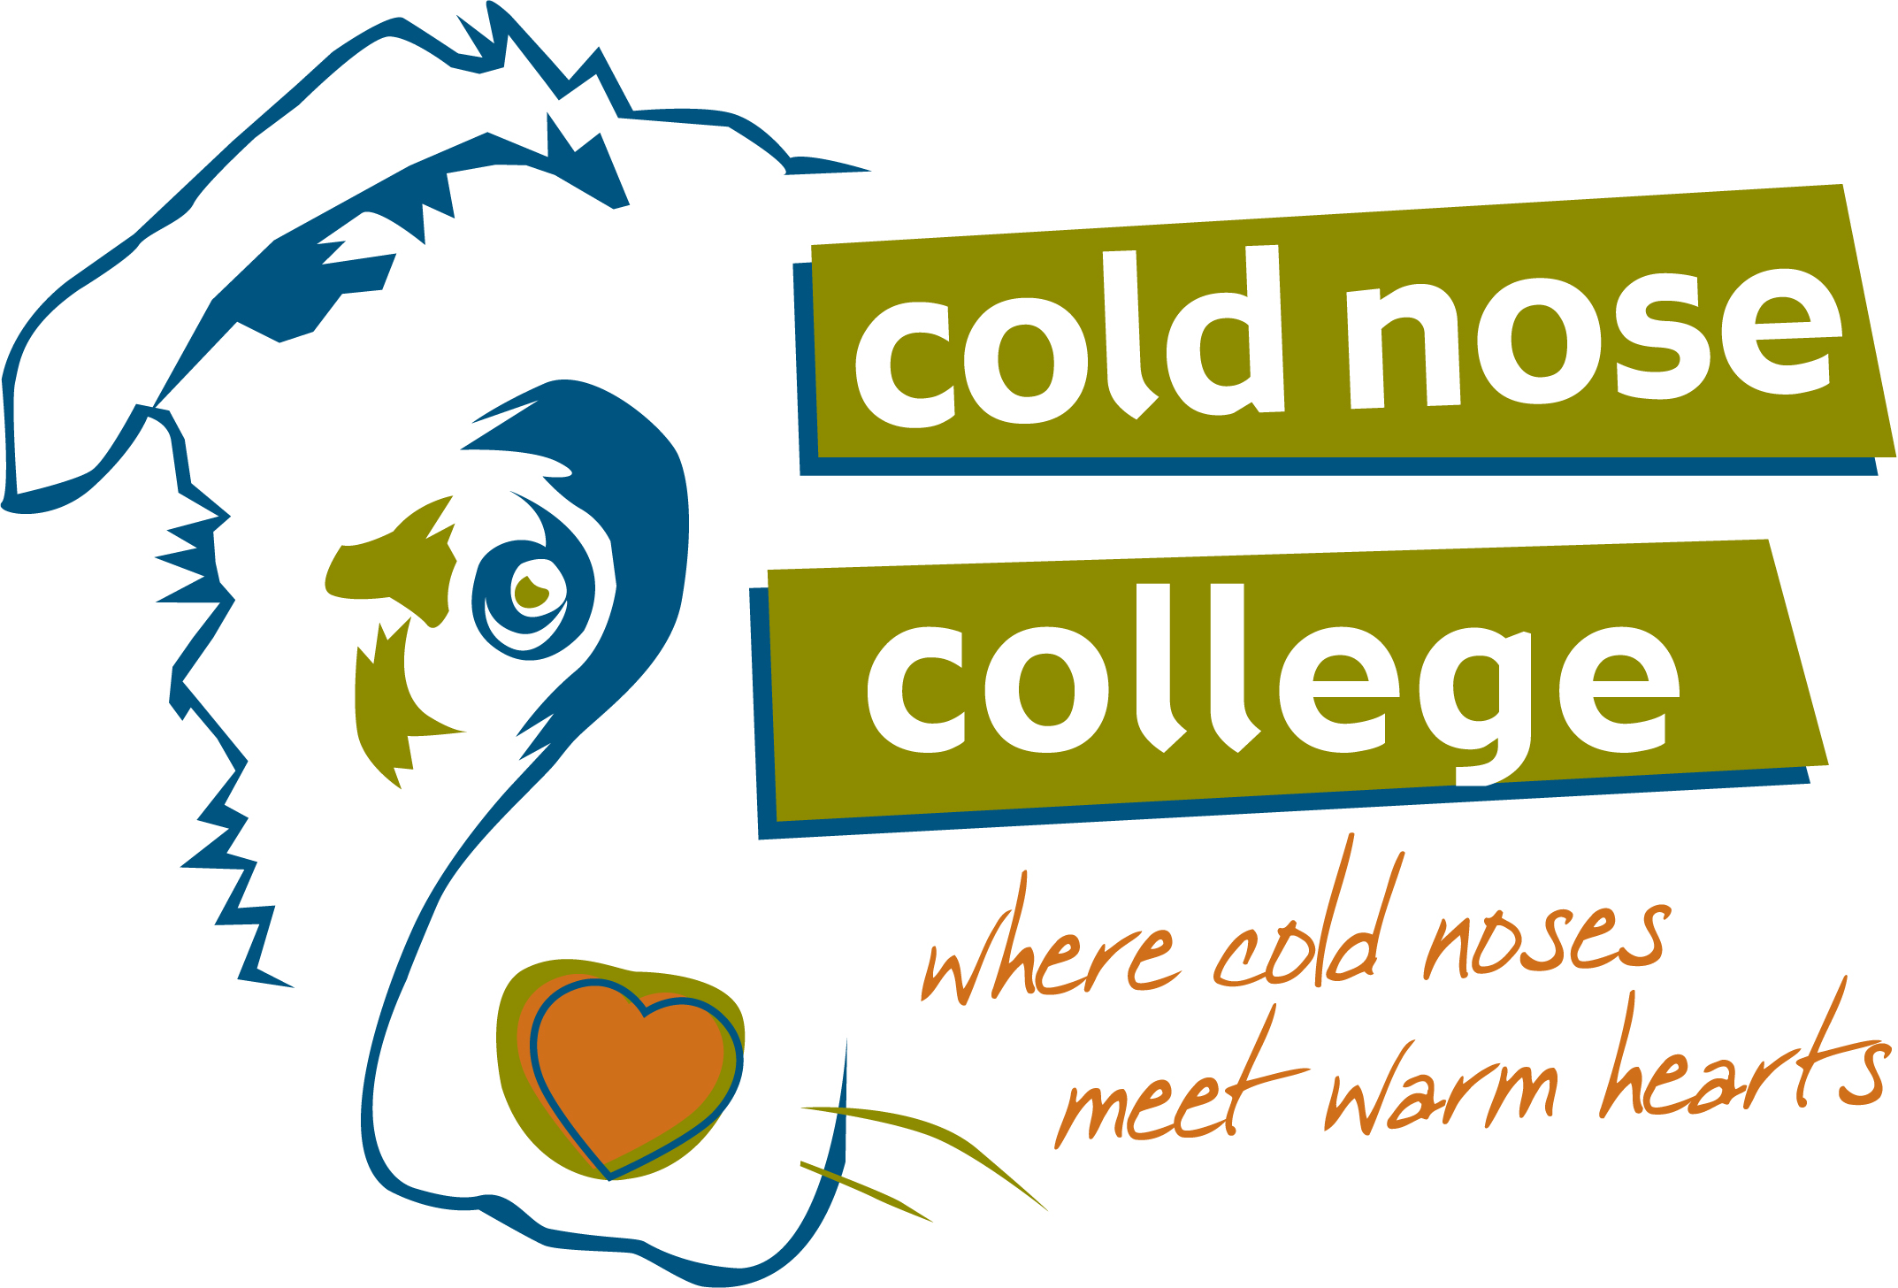
Mountains of Learning
Rocket Recall – Registration Form

Cold Nose College
828-644-9148
www.coldnosecollege.com
lisa@coldnosecollege.com

Name: |  | Dog’s Name:
Address: |  | Breed Type:
City/State/Zip: |  | Age: Sex: Spayed Neutered
Home Phone: |  | Any Previous Clicker Training Experience?
Cell Phone: |  | Yes No
Email:

Tuition: Working Spot: $295 Observer: $160
In order to reserve your spot in the workshop, please make payment via PayPal (send funds to lisa@coldnosecollege.com) or by mailing a check payable to Cold Nose College to:

Cold Nose College
MoL – Rocket Recall
1675 Friendship Church Road
Murphy, NC 28906

Where did you hear about the workshop
Briefly describe any previous clicker training experience
Has your dog bitten another dog? Yes No Has your dog bitten a person? Yes No
If yes, please describe:
Permission to use photos of you and/or your dog on our website and other locations? Yes No

Liability Release
I, the undersigned owner/handler (client) of the dog described above do hereby agree that Lisa Waggoner, Cold Nose College, LLC and all Cold Nose College employees and agents will not be liable for any damage or loss resulting from failure of the dog to respond to any cues or behaviors taught by Cold Nose College or resulting from counseling and advice supplied to the owners/handlers of the dog. The dog’s behavior now and in the future is solely the responsibility of the owners/handlers (client) of the dog. Should any behavior on the dog’s part now or in the future result in damage to the property, owners, or person or property of some third party, owner agrees to assume full responsibility for any and all such damage, and to absolve Lisa Waggoner and Cold Nose College and all Cold Nose College employees and agents from any and all obligations to pay such damage to owner/handler or third party. All dogs are trained or otherwise handled or cared for by owner/handler who receives instruction from Lisa Waggoner and Cold Nose College without any liability whatsoever against Lisa Waggoner, Cold Nose College or any Cold Nose College employee or agent for loss, damage from disease, death, running away, theft, fire, injury to or from persons, other dogs or property, or by any other causes.

Signature: |  | Date:

If signing digitally, simply type your name in the Signature field.

Cancellation: Your workshop tuition is 75% refundable if you cancel 120 days or more prior to workshop start date; 50% refundable if you cancel 60 days prior to workshop start date; 25% if you cancel 30+ days prior; non-refundable if you cancel less than 30 days out.

